STDBAVL – How to Open & Blackout Vehicle

Open/ Black out Regular Cars for a Location

- Log on to Maestro and go to the STDBAVL screen. Type in:

ACT: STD
STATION: 4-digit Maestro station number
GROUP: 1-letter vehicle class code for each applicable vehicle class or
Y for all vehicle classes
EFFECTIVE DATE: Enter start date (e.g. 01Mar09)
TERMINATION DATE: Enter end date (e.g. 15Mar09)
STATUS: A (to make available) or S (to black out)
EFFECTIVE TIME: Enter start time (24-hour format)
TERMINATION TIME: Enter end time (24-hour format)

- Press Enter.

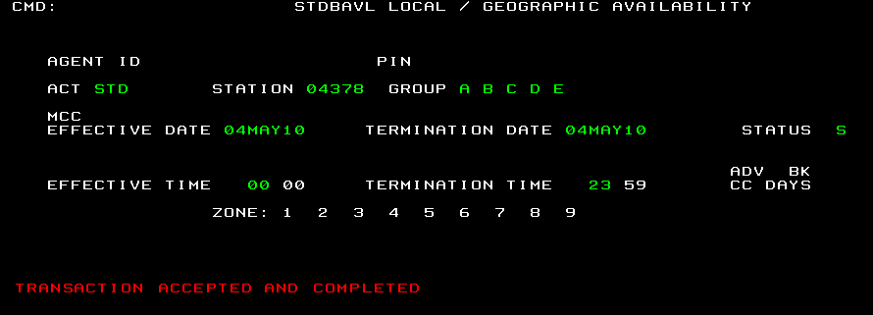

Open/ Black out Specialty Cars for a Location

- Log on to Maestro and go to the STDBAVL screen. Type in:

ACT: STD
STATION: 4-digit Maestro station number
GROUP: Suffix of vehicle class code for each applicable vehicle class
MCC: Prefix of vehicle class code (i.e. X)
EFFECTIVE DATE: Enter start date (e.g. 01Mar09)
TERMINATION DATE: Enter end date (e.g. 15Mar09)
STATUS: A (to make available) or S (to black out)
EFFECTIVE TIME: Enter start time (24-hour format)
TERMINATION TIME: Enter end time (24-hour format)

- Press Enter.

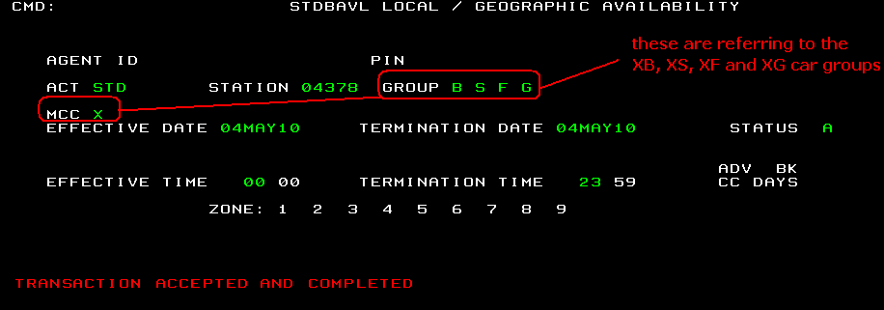

Open/ Black out One Way for a Location

- Log on to Maestro and go to the STDBAVL screen. Type in:

ACT: GEO
STATION: 4-digit Maestro station number
GROUP: 1-letter vehicle class code for each applicable vehicle class
MCC:
EFFECTIVE DATE: Enter start date (e.g. 01Mar09)
TERMINATION DATE: Enter end date (e.g. 15Mar09)
EFFECTIVE TIME: Enter start time (24-hour format)
TERMINATION TIME: Enter end time (24-hour format)
ZONE: Enter A (open) or S (to black out) under the zone of the drop off
location
- Press Enter.

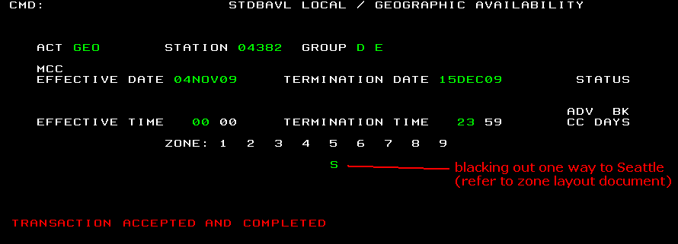

Note: Be careful of how you specify the Effective Time and Termination Time. If you want to black out vehicles from 12am today till 1am the next day, you must complete the transaction for two separate days:

(1) Effective Date -Termination Date: Today’s date - Today’s date
Effective Time - Termination Time: 0000 – 2359

(2) Effective Date -Termination Date: Tomorrow’s date - Tomorrow’s date
Effective Time - Termination Time: 0000 – 0059
Do not enter the following as this will only black out vehicles from 12am to 1am today and tomorrow.
Effective Date -Termination Date: Today’s date – Tomorrow’s date
Effective Time - Termination Time: 0000 – 0059

